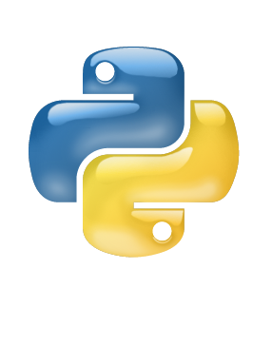

Python

Dictionary

Lab

Tutorial

Class IX

Lab 12

1. Create a dictionary about your family. Add key father’s_name, mother’s_name, family_member, and home_town
2. Try all the operations you have learned in lecture

[ Access item, Loop , Add, Remove, Construct ]